User Mode and Kernel Mode in Operating System | Operating System – M01 P10

This is a multipart blog article series, and in this series I am going to explain you the concepts of operating system. This article series is divided into multiple modules and this is the first module which consists of 12 articles.

In this article I am going to explain you about “User Mode” and “kernel Mode” in an operating system.

This below diagram will help you to understand about the user mode and kernel mode, and give a better picture about these two modes in operating system.

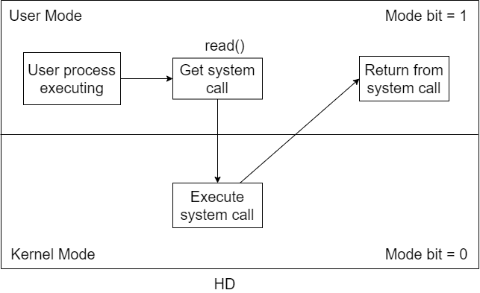

* Whenever we use an application at that time by default we are in user mode.
* All the core functionalities and drivers work in kernel mode
* The process get switched in between two modes i.e. user mode and kernel mode.
* Operating system works at kernel mode.
* Suppose we are writing a C program, and in that program suppose it is written that “you have to read a file and have to write something in that file.”
* Remember one thing that the file is stored in Hard Disk and hard disk is a hardware and all the hardware are in control of kernel. So a user cannot directly access the hardware it have to take the help of kernel.
* To read that file we have to use system call. System call is a way to by which we can access the kernel. We will use “read()” system call, it means that we want to read some data from any file.
* After it the process gets shifted from user mode to kernel mode.
* Now, we will read the file as we are now in the kernel mode. All the operations of read and write will be completed here.
* After that the process will get shifted to user mode again. The process have to shift to user mode because we the user are working in user mode.

This was all about user mode and kernel mode. Hope you liked it and learned something new.

If you have any question, query, doubt or just want to share something with me, then please feel free to contact me.